**Pension Advisor System**

This client managing insurance for pension and money for clients.

He has group mangers. Each group manager has his own clients.

The Advisor wants system that he can ,manually add all details, money, risk plan and more into the system for client view.

**Goals of the system**

• Managing changes in customer plans.

• A simple view of all insurance plans in one place

• Periodic monitoring and updating of all plans

• Defining and managing retirement savings goals and insurance amounts

• Developmental monitoring:

Yield, insurance costs, expected annuity amount and more

**All Is adding manually by Admin or managers. He will enter all data and end user can only view.**

**No need any automation calculate**

1. A login page. There are 3 levels:

Admin can edit all.

Group Manager- can add it only customers that related to him

End use- can only view



1. Page to add user details name,age, birth date and more

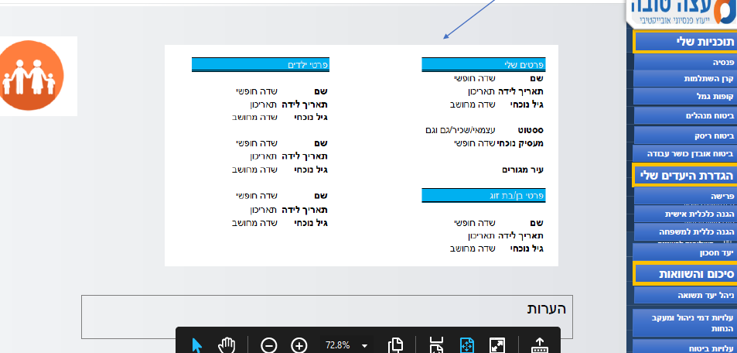

1. List of tabs.  
   That can collabs and expand . Each tab is a name of a saving plan

Each saving plan has it owns details like for how long, how much pay for risk, how much to save each month…. How much you will get in the end

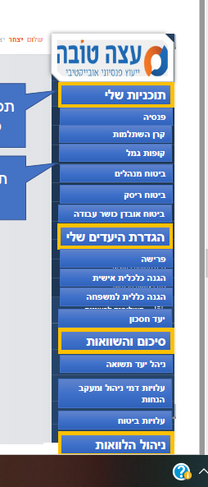

1. Each tab open a page with editable fields according to the plan needs that admin can fill. For end user it’s only view

Most of the fields are input text or textArea

Example of fields 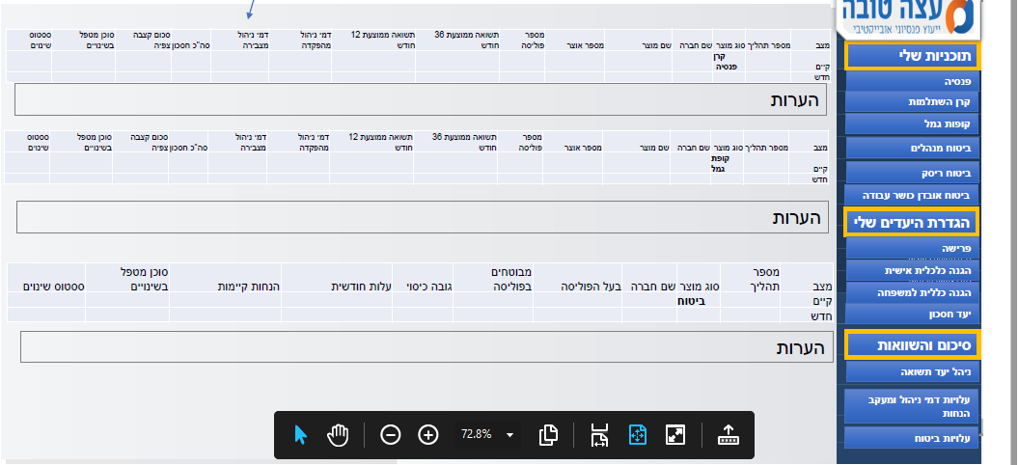

1. Page with tab on header.

Another option of page with tab in the header . A new tab can be added by click on a “btn new tab ” that we will create

Each like “tab 2020”, “tab 2021”, btn new tab -- will create new tab . Admin can give it a name.

All tabs has the same fields inside . same as sheets in Excel . The new tab is clone the field form other tabs.



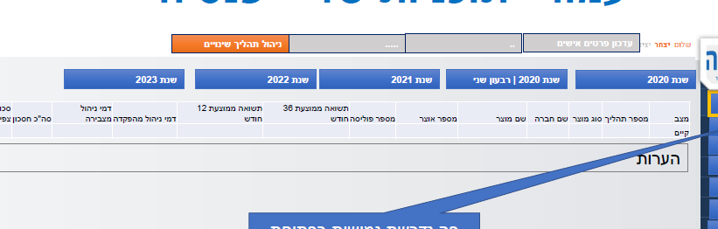

1. This page that summarize some plans together for advisor and user to be easy for follow changes or to equal .

Also here will be option to duplicate this block(list of fields and give it a name)

Click on “clone” will duplicate this block and client will fill the details

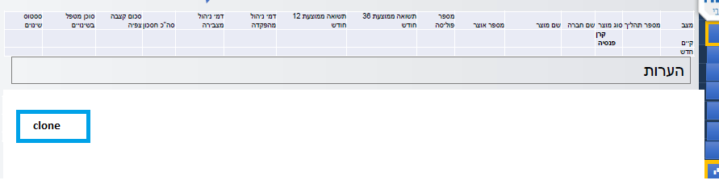

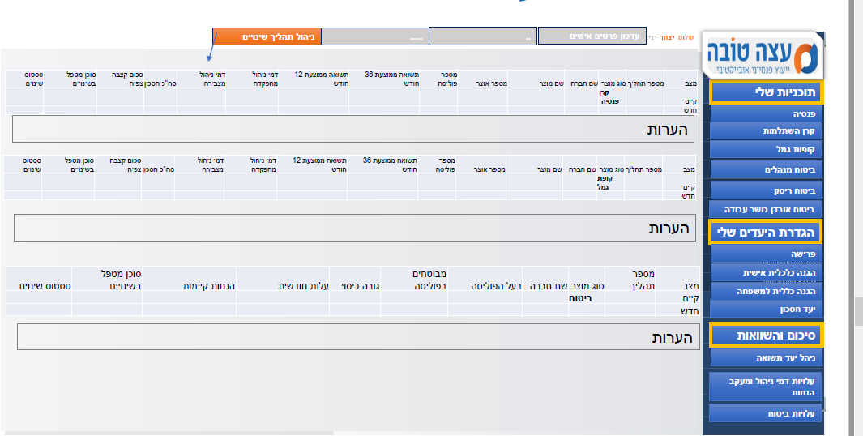

Advisor will define which fields he needs.